
Oracle ERP Procurement Process on EBS
For MSA Cosmetics Trading

April 13, 2025

A collaborative effort of Ahmed Zakaria Ali, Mai Mohamed Ahmed, Shady Mohamed Bartakh, Mohamed Ibrahim Fayad, Abd El Rahman Fathi Morsy, Moustafa Raouf Ramadan.
Table of Contents
1. Introduction 0
2. Project Scope 0
3. Step-by-Step Implementation 0
4. Multi-Organization Hierarchy Setup 4
5. Chart of Accounts Configuration 5
6. Conclusion 5
Appendix A 6
Appendix B 7

1. Introduction
Overview of Oracle ERP Supply Chain Management (EBS)
Oracle ERP (Enterprise Resource Planning) Supply Chain Management (SCM) on E-Business Suite (EBS) is an integrated solution for managing supply chain operations, procurement, inventory, and financials. It enables organizations to streamline business processes, ensure regulatory compliance, and enhance decision-making through a unified platform.
Purpose of the Project
The purpose of this project is to implement and document the step-by-step configuration of Oracle ERP Supply Chain Management (SCM) on EBS for MSA, a cosmetics trading company in the UAE. This report outlines the setup and execution of key modules, including Inventory and Procurement, also the initial setup of the multi-Organization hierarchy, and its chart of Accounts, specifically for managing the procurement of raw materials and final products, that are stored in inventory storage across multiple organizational units.

2. Project Scope
The project focuses on configuring and implementing the following Oracle EBS modules for MSA’s cosmetics supply chain:
- Multi-Organization Hierarchy – Establishing business groups, legal entities, and operating units to manage multiple locations.
- Chart of Accounts – Defining accounting structures for financial transactions.
- Inventory Management – Setup and configuration of inventory control, unit of measure, and storage across different organizations.
- Procurement – Defining procurement rules, workflows, and supplier management for acquiring raw materials, packaging components and finished products.

3. Step-by-Step Implementation
Breakdown of Requirements into Tasks and Configurations
Each user requirement has been analyzed to define specific tasks and configurations required for implementing Oracle ERP for MSA’s cosmetics business. The steps include defining setup, business rules, responsibilities, and system configurations tailored to the procurement process.
Setup
MSA_Calendar is set for different periods of time that starts from the closing of year 2024 till the end on business day in December 2025.
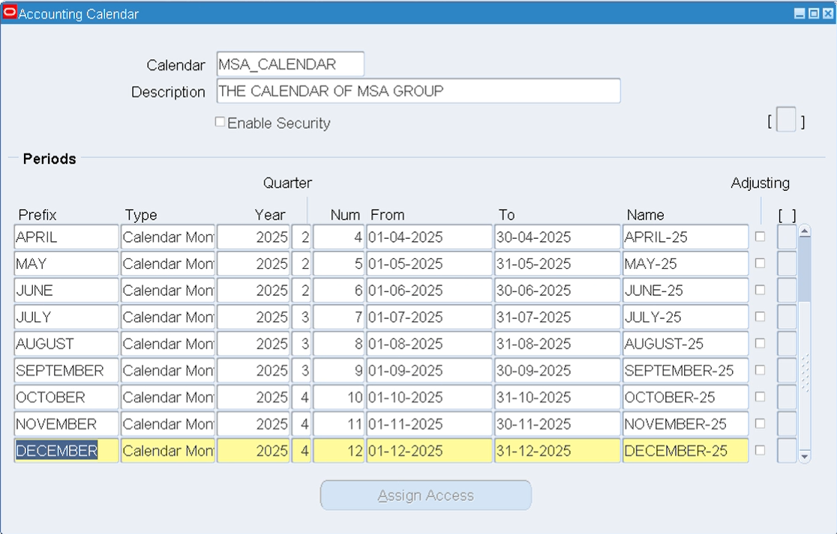
Window 1: General Ledger Super User /Setup/Financials/Calendars/Accounting
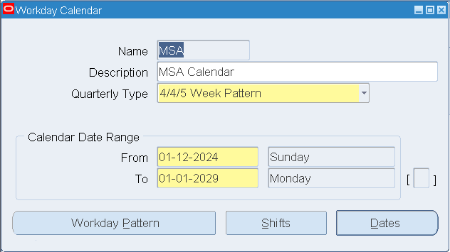
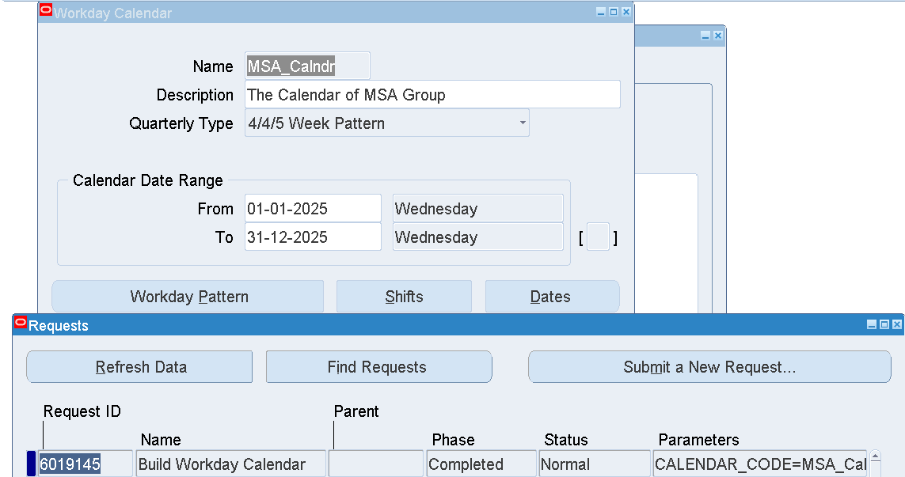
Window 2: Inventory/Setup/Organizations/Calendars
MSA_DUSD is set as the default working base currency.
MSA_BIT is another available currency.
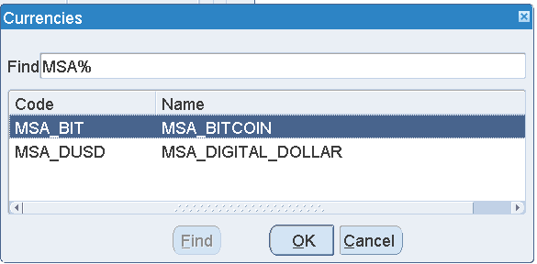
Window 3: General Ledger Super User/Setup/Currencies/Define
MSA_Address is set as the default address style used.
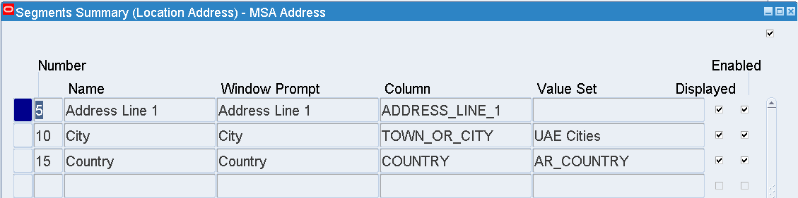
Window 4: Inventory/Setup/Flexfields/Descriptive/Segments
Business Rules and Responsibilities
Each setup follows predefined business rules to ensure compliance and efficiency as per the followed procedures. Responsibilities are assigned based on user roles within the ERP system. Essential Setup has used System Administrator, General Ledger Super User, Global HMS Manager as responsibilities for building the Business Group for MSA Cosmetics as shown below in Figure 33. Inventory Setup has used the Inventory responsibility for defining the rest of the organizations. Additionally, the workday calendar for the operating unit is defined as well as the items’ different types (See Appendix B for Item definitions).
Unit of Measure Setup for Inventory
To standardize inventory management, unit of measure (UOM) is configured as follows:
- Base Unit: Standard unit used for inventory tracking is the Box which contains 240 item packages.
- Conversion Factors: Relationship between different UOMs for efficient inventory management as depicted below.
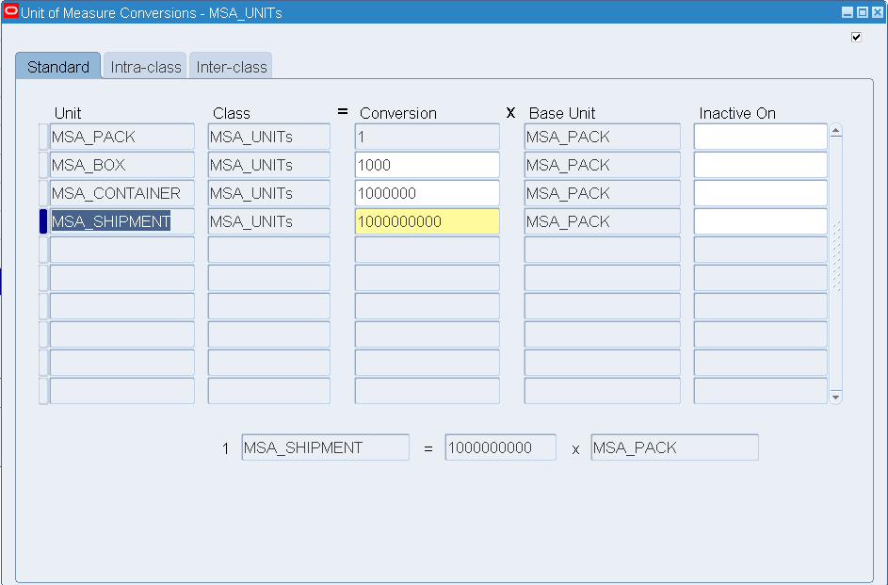
Window 5: Inventory/Setup/Units of Measure/Conversions
Company users have been created that defines the roles working in MSA. Each project member has given a user with the opportunity to log into the company, and utilize its responsibilities.
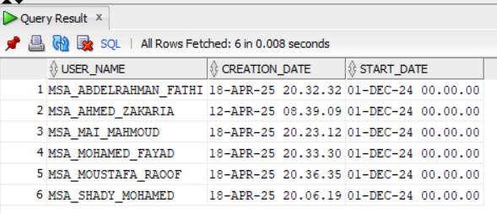
Figure 1: Oracle Database Values for the USER Table
The MSA company trades in the cosmetics products that range in a wide ensemble for personal care. As listed below (in Window 6) the items can be creams, masks,… that run under the area of application; Face, Foot, Hair & Skin Care.
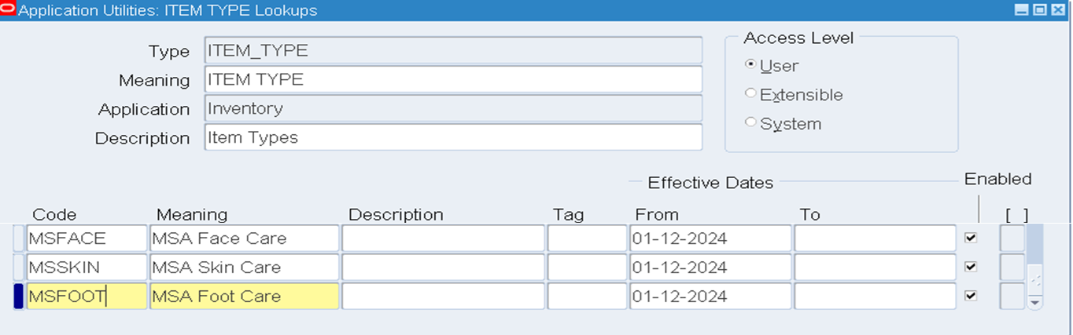
Window 6: Inventory/Setup/Items/Item Types
Purchasing
The Purchasing module setup is applied on the system as the last step in the P2P cycle. In this step we can Request items for Qotations from the Suppliers the company deal with (Figure 2). This request is considered as a result of an approved Purchase Requisition. Further steps include Auto Creating a Purchase Order for the same.
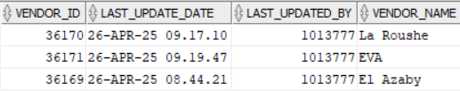
Figure 2: Oracle Database Values for the suppliers

4. Multi-Organization Hierarchy Setup
To support MSA’s multi-organizational operations in the UAE, the following hierarchy is established:
- Business Group: MSA Group, representing the overall enterprise.
- Legal Entity & Ledger: MSA Cosmetics Trading, responsible for compliance and financial reporting.
- Operating Unit: Different storage facilities managing packaging materials and finished goods. This spins into 2 inventory organizations. The MSA_OU1 is the Operating Unit representing the company.
Figure 3: Multi-Organization Hierarchy

5. Chart of Accounts Configuration
The chart of accounts is configured to manage financial transactions for MSA’s cosmetics business with predefined account segments, including:
- Company Code & Vice Presidency: Identifies MSA’s business entities.
- Department: Classifies expenses and revenues related to procurement, and Material handling.
- Account: Tracks financial transactions such as raw material purchases, receipt invoices and procurement expenses.
- Sub-Account & Product Segments: Further classification for analyzing cost distribution across product lines.
Please refer to Appendix A for the list of accounts used.

6. Conclusion
Summary of Findings
The project successfully outlines the step-by-step configuration of Oracle ERP SCM on EBS for MSA’s cosmetics trading. Key components, such as inventory, procurement, and financial structures, are implemented as per business requirements to optimize the procurement of items, and storage across multiple facilities.
Challenges and Recommendations
Challenges:
- Complex configurations requiring detailed validation for multi-organization inventory management.
Recommendations:
- Periodic review and testing of configurations to align with evolving business needs.
- Training sessions for users, including procurement teams, and warehouse staff, to enhance system adoption and efficiency.

This document provides a structured implementation guide for Oracle ERP Supply Chain Management on EBS, specifically tailored for MSA’s cosmetics business in the UAE. Further details can be added based on specific system setups and configurations.

Appendix A
 |  | Type | Purpose | Company Code | Vice Presidency | Department | Account | Sub-Account | Product
Inventory Setup | Costing Information  (Valuation Accounts) | Material | An asset account that tracks material cost | 001 | 01 | 001 | 1000 | 0000 | 000
 |  | Outside Processing | An asset account that tracks outside processing cost | 001 | 01 | 000 | 1450 | 0000 | 000
 |  | Material Overhead | An asset account that tracks material overhead cost | 001 | 01 | 000 | 1420 | 0000 | 000
 |  | Overhead | An asset account that tracks resource and outside processing overheads | 001 | 01 | 000 | 1430 | 0000 | 000
 |  | Resource | An asset account that tracks resource cost | 001 | 01 | 000 | 1440 | 0000 | 000
 |  | Expense | The expense account used when tracking a non-asset item | 001 | 02 | 001 | 1004 | 0000 | 000
 | Receiving Accounts | Purchase Price Variance | Consider price change from PO when the standard method is used | 001 | 01 | 520 | 5210 | 0000 | 000
 |  | Invoice Price Variance | The difference between PO & Invoice price | 001 | 01 | 520 | 5220 | 0000 | 000
 |  | Inventory AP Accural | Handle the cost of material till supplier delivers the invoice | 001 | 01 | 000 | 2220 | 0000 | 000
 | Receiving Options  (Accounting) | Receiving Inventory Account |  | 001 | 01 | 000 | 1410 | 0000 | 000
 |  | Clearing Account | Used for intercompany receivables in the procuring organization when the receiving organization is not the same as the procuring organization | 001 | 01 | 000 | 1410 | 0000 | 000
 | Profit & Loss Accounts | Sales | Tracks the default revenue account | 001 | 01 | 520 | 4110 | 0000 | 000
 |  | Cost of Goods Sold | Tracks the default cost of goods sold account | 001 | 01 | 450 | 5110 | 0000 | 000
 | Other Accounts | Deferred COGS Accounts | The price of good sold in the interface table (Invoice not Generated) | 001 | 01 | 450 | 5110 | 0000 | 000
 |  | Cost Variance Account | Under average costing with negative quantity balances | 001 | 01 | 000 | 1410 | 0000 | 000
Procurement | Financial Options  (Accounting) | Liability | Payable Account for all new suppliers | 001 | 01 | 000 | 1001 | 0000 | 000
 |  | Prepayment | The Prepayment account and description for a supplier site's invoices | 001 | 01 | 000 | 1004 | 0000 | 000
 |  | Bills Payable | Controlling the timing of your payments and, therefore, control your cash flow | 001 | 01 | 000 | 2580 | 0000 | 000
 |  | Discount Taken | Payables uses this account to record the discounts you take on payments | 001 | 01 | 000 | 1004 | 0000 | 000
 |  | PO RATE Variance Gain | To record the exchange rate variance gains for your inventory items | 001 | 01 | 000 | 1003 | 0003 | 000
 |  | PO RATE Variance Loss | To record the exchange rate variance losses for your inventory items | 001 | 01 | 740 | 7844 | 0000 | 000
 | Purchasing Options | Expense AP Accural | Records an accrual when you record an item as received in Oracle Purchasing | 001 | 01 | 000 | 1340 | 0000 | 000
 | Inventory Purchasing Attributes | Expense Account | The default account for expense items you enter in the Payables Expense Reports | 001 | 01 | 520 | 7530 | 0000 | 000
 | Notes:
 | * Some Vision Operations ledger accounts are employed.

Appendix B
ITEM CATEGORY | BRAND | Type | PRICE | SIZE
Face & Skin Care | Neutrogena | Face wash | 180
Face & Skin Care | La Roche | Sun Block | 300
Face & Skin Care | La Roche | Posay Serum | 400
Face & Skin Care | NIVEA | Moisturing Cream | 100 | Small
Face & Skin Care | NIVEA | Moisturing Cream | 200 | Large
Face & Skin Care | Garnier | Face Cleaner | 180
Face & Skin Care | Garnier Masks | Face Mask | 84
Face & Skin Care | Cerave | Moisturing Cream | 250
Face & Skin Care | L'Oréal Paris | Face Mask | 415
Face & Skin Care | Vichy | Anti Aging Cream | 500
Face & Skin Care | The Ordinary | Vitamin C Cream | 300
Face & Skin Care | Bioderma | Moisturing Cream | 350 | Small
Face & Skin Care | Bioderma | Moisturing Cream | 400 | Large
Face & Skin Care | Beesline | Serium | 300 | small
Face & Skin Care | Beesline | Serium | 250 | Large
Face & Skin Care | Eva | Mud Mask | 70 | Small
Face & Skin Care | Eva | Mud Mask | 100 | Large
Face & Skin Care | Bio Soft | Scrub Cream | 120 | Small
Face & Skin Care | Bio Soft | Scrub Cream | 150 | Large
Face & Skin Care | Clinique | Anti Aging Cream | 600 | Large
Face & Skin Care | Clinique | Anti Aging Cream | 500 | Small
Face & Skin Care | CeraVe | Face Wash | 250 | Small
Face & Skin Care | CeraVe | Face Wash | 300 | Large
Face & Skin Care | CeraVe | Moisturing Cream | 400
Face & Skin Care | Eucerin | Face wash | 250 | Small
Face & Skin Care | Eucerin | Face wash | 300 | Large
Face & Skin Care | Eucerin | Moisturing Cream | 400
Face & Skin Care | Avene | Miceller Water | 150 | Small
Face & Skin Care | Avene | Miceller Water | 200 | Large
Face & Skin Care | Avene | Face Cream | 400
Face & Skin Care | Isis Pharma | Sensitive Skin Care | 250
Face & Skin Care | Klorane | Face Cream | 300 | Small
Face & Skin Care | Klorane | Face Cream | 400 | Large
Face & Skin Care | Hada Labo | Serium | 250 | Small
Face & Skin Care | Hada Labo | Serium | 300 | Large
Face & Skin Care | Glysolid | Face Cream | 100 | Small
Face & Skin Care | Glysolid | Face Cream | 150 | Large
Face & Skin Care | Elancyl | Skin Cream | 250 | Small
Face & Skin Care | Elancyl | Skin Cream | 300 | Large
Face & Skin Care | Vaseline | Face Cream | 50 | Small
Face & Skin Care | Vaseline | Face Cream | 100 | Large
Hair Care | L'Oréal Paris | Shampoo | 150 | Small
Hair Care | L'Oréal Paris | Shampoo | 250 | Large
Hair Care | Dove | Hair Mask | 150
Hair Care | Pantene | Shampoo and Palsam | 80
Hair Care | Head & Shoulders | Head & Shoulders Anti Dandruff | 120 | Small
Hair Care | Head & Shoulders | Head & Shoulders Anti Dandruff | 150 | Large
Hair Care | Raw African | Hair density increase product | 255
Hair Care | TRESemmé | Shampoo & Palsam | 120 | Small
Hair Care | TRESemmé | Shampoo & palsam | 200 | Large
Hair Care | Schwarzkopf | Hair Protection | 200 | Small
Hair Care | Schwarzkopf | Hair Protection | 300 | Large
Hair Care | L'Oréal Professionnel | Shampoo for Damaged Hair | 150 | Small
Hair Care | L'Oréal Professionnel | Shampoo for Damaged Hair | 300 | Large
Hair Care | Garnier Fructis | Hair Palsam | 80 | Small
Hair Care | Garnier Fructis | Hair Palsam | 150 | Large
Hair Care | Schauma | Shampoo & palsam | 50 | Small
Hair Care | Schauma | Shampoo & palsam | 100 | Large
Hair Care | Lavera | Natural Hair Product | 200 | Small
Hair Care | Lavera | Natural Hair Product | 300 | Large
Foot Care | Glysolid | Foot Cream | 80 | Small
Foot Care | Glysolid | Foot Cream | 150 | Large
Foot Care | Vaseline | foot moisturizing Cream | 70 | Small
Foot Care | Vaseline | foot moisturizing Cream | 100 | Large
Foot Care | Oriflame | Foot Scrub Cream | 150 | Small
Foot Care | Oriflame | Foot Scrub Cream | 200 | Large
Foot Care | Dr. Rashel | Foot Pealing spray | 100
Foot Care | Dr. Rashel | Exfoliating Foot Mask | 180
Foot Care | Eveline | Softening Cream for Cracked Heels | 200
Foot Care | Scholl | Foot Repair Cream | 150 | Small
Foot Care | Scholl | Foot Repair Cream | 300 | Large
Foot Care | Kiehl's | Moisture Squalane Cream | 400 | Small
Foot Care | Kiehl's | Moisture Squalane Cream | 500 | Large
Foot Care | Dr. Scholl | Foot Repair Hydrating Cream | 150 | Small
Foot Care | Dr. Scholl | Foot Repair Hydrating Cream | 350 | Large
Foot Care | Sofy | Silky Foot Care Cream | 100 | Small
Foot Care | Sofy | Silky Foot Care Cream | 150 | Large
Foot Care | Blistex | Intensive Moisturiser | 80 | Small
Foot Care | Blistex | Intensive Moisturiser | 120 | Large

